Break the Earth Web Quest

Hiram Viezca & Shawn Fradet

CST-452 Capstone Project Proposal

Grand Canyon University

Instructor: Prof. Amr Elchouemi

Revision: 2.0

Date: 4/11/2022

**ABSTRACT**

This proposal covers a web application project for a local heavy metal band “Break the Earth”. This band is looking to increase their web presence while centralizing access to existing online media. The band requires a web application that will help them connect with their fans and music industry professionals by providing information about the band and their music. The proposed web application provides information on the band members, their available discography, material in work, live events, and YouTube videos. The web application will also provide the ability to book them for a show and purchase their merchandise.

This proposal document breaks down all aspects of the web application along with risk mitigation and a schedule for accomplishing everything in our allotted time frame.

|  |
| --- |
| History and Sign Off Sheet |

**Change Record**

|  |  |  |
| --- | --- | --- |
| **Date** | **Author** | **Revision Notes** |
| 3/1/2022 | Hiram Viezca, Shawn Fradet | Initial draft for review/discussion |
| 4/11/2022 | Hiram Viezca, Shawn Fradet | Final- Gramar review |
|  |  |  |

|  |
| --- |
| **Overall Instructor Feedback/Comments** |

|  |
| --- |
| **Overall Instructor Feedback/Comments** |

**Integrated Instructor Feedback into Project Documentation**

☐ Yes ☐ No

**Project Approval**

☐ Professor - Dr. Amr Elchouemi

**TABLE OF CONTENTS**

**Project Overview and Project Objectives** **4**

**Project Scope** **6**

**Project Success Measures** **8**

**Project High-Level Solution** **10**

**Project Controls** **15**

**Appendix A – References** **18**

**Appendix B – Copyright Compliance** **18**

# Project Overview and Project Objectives

#### State the Problem and Background

The purpose of this project is to create a website highlighting a local music group that will allow fans and industry to engage and interact more closely with the group. The goal is to create a dynamic and secure website application that will allow people access wherever the Internet is available on a variety of devices. The application will be easily navigated with the intention of providing desired information in as few clicks as possible.

The heavy metal band “Break the Earth” is a local up-and-coming band based in Albuquerque, NM. The band is looking to increase their digital footprint and provide a hub to connect with their fan base and industry professionals. The band’s current digital footprint includes their discography on several streaming services and a merchandise store. The main purpose of this web application is to create a hub that allows fans to track the activities of the band, a location for industry professionals to book the band, and an avenue to distribute their merchandise and music digitally.

#### Christian Worldview

The web application created in this project will incorporate the ethical aspect of the Christian worldview. The Bible states, “Thou shalt not steal” (Exodus 20:15 KJV). Unfortunately, despite the many great aspects of the internet, it has made plagiarism and theft of intellectual property as simple as a few mouse clicks. This web application is to be created in an ethical way that ensures it is honest to itself, the group it represents, and the group’s fans. This honesty is achieved through the usage of images and media that the group has created itself or that is otherwise available for public use. In no instance will this application leverage any image or media that infringes on the copyright of another artist, person, or entity.

#### Project Objectives

The proposed web application is designed as a hub for all things related to the band “Break the Earth”. The web application will meet the following objectives:

* Provide information about the group and individual group members
* Purchase digital music from the group’s discography
* Purchase band related merchandise
* Track progress on upcoming material
* View upcoming band events
* Provide the capability to book the band
* Secure role-based capabilities to include
  + Editors with the ability to update basic application content.
  + Administrators with the additional ability to manage editors.

After reviewing this project plan, the client will need to approve the plan before the project begins.

#### Challenges

These are several challenges that the team will need to overcome for this project.

* Working with Modals and Ajax for a more smooth and professional user experience
* Completion of all aspects of the web application within the allocated time frame of the class
* Implementing a Spring Email service
* Securing all aspects of the application

#### Benefits and Opportunities

The web application is an opportunity for Break the Earth to increase both their fan base and professional portfolio. With a dynamic and interactive website that has a modern look and feel fans will be more likely to return for information on upcoming events, updated music, and possibly purchase merchandise. The ability to book the group for events from within the application helps link the group to both current and new music venues and professionals. All these aspects are vital to increasing the legitimacy of the brand allowing for the band’s continued existence and future growth.

# Project Scope

The “Break the Earth” web application’s scope covers all aspects of the group and their music. The project will be a Spring Boot based web application that will use a SQL database for persistent data storage. The application will provide several sections to include:

* Main page
* About Us page
* Contact Us page
* Event Booking page

These pages will include sub sections providing the ability to view the group’s current body of work, see the progress and status of projects in work, view group videos, and purchase merchandise supporting the group.

The application will be maintained and updated by an Administrator and Editors. These role-based users will have access to tools allowing for the update of all sections of the web application. Administrators will have the additional ability to manage users with the Editor role.

An SQL database will be used to maintain all persisted data for the website. This data will include user information, contact information for venue relationships, group events past and present, booking requests, and album/track information for available works as well as works in progress. The data will be leveraged in a report showing events from selected time frames.

Security will be provided using Spring Boot’s security framework. User access will be controlled by roles and associated passwords will be stored using the BCrypt algorithm.

This web application will not provide public user accounts to avoid the collection of personal identifiable information (PII) or payment card industry (PCI) information. A built-in store will be outside of the scope of this project and will instead provide links to a third-party store carrying merchandise.

**Stakeholders and Contacts**

|  |  |  |
| --- | --- | --- |
| Stakeholder Name | Role(s) | Responsibilities |
| Hiram Viezca | Developer | Create, test, and deploy website |
| Shawn Fradet | Developer | Create, test, and deploy website |
| N’nette Viezca | Tester | User Acceptance Tester |
| Client | Client | Approve project, approve sprint reviews, and provide feedback for integration into project |

**Work Breakdown Structure**

|  |  |  |  |  |  |  |  |  |  |  |
| --- | --- | --- | --- | --- | --- | --- | --- | --- | --- | --- |
| Work Breakdown Structure | | | | | | | | | | |
| ID | Task | Dependencies | Status | Effort Hours | Cost | Start Date | Planned Completion | Estimate to Completion | Actual Completion | Resource |
| **1.0** | **Site HTML Design** |  | In work | 15 | 0 | 2/28/22 | 4/10/22 |  |  |  |
| **2.0** | **Videos and Streaming** |  | Backlog | 4 | 0 | 3/14/22 | 3/20/22 |  |  |  |
| **3.0** | **Upcoming Events** |  | Backlog | 4 | 0 | 3/14/22 | 3/20/22 |  |  |  |
| **4.0** | **New Material** |  | Backlog | 4 | 0 | 3/21/22 | 3/27/22 |  |  |  |
| **5.0** | **Now Available** |  | Backlog | 4 | 0 | 3/21/22 | 3/27/22 |  |  |  |
| **6.0** | **Merchandise Section** |  | Backlog | 4 | 0 | 3/28/22 | 4/3/22 |  |  |  |
| **7.0** | **Sign-Up Section** |  | Backlog | 2 | 0 | 3/28/22 | 4/3/22 |  |  |  |
| **8.0** | **Administration** |  | In Work | 5 | 0 | 3/6/22 | 3/13/22 |  |  |  |
| **9.0** | **Database** |  | In Work | 4 | 0 | 3/6/22 | 3/13/22 |  |  |  |

# Project Success Measures

Success of the web application will be measured with a variety of criteria. On the development side of the project, success will be measured with the application passing designed user acceptance tests. The project should have all major elements completed and page load times should be kept to a minimum. Other measures of success will be the overall completion of the project within the time limits of the class, and the successful implementation of client feedback resulting in a final acceptance of the completed web application.

#### Project Completion Criteria

|  |
| --- |
| Project Completion Criteria |
| 1 - Passed User Acceptance Tests |
| 2 - Implementation of all major elements identified as Epics |
| 3 - Pages loading in acceptable timeframe (< 2 seconds) |
| 4 - Application developed within the allocated time frame |
| 5 - Implementation of client feedback |
| 6 - Client final approval |

#### Project Assumptions and Constraints

|  |  |  |  |  |  |
| --- | --- | --- | --- | --- | --- |
| Assumptions and Constraints | | | | | |
| ID | Description | Comments | Type | Status | Date Entered |
| 1 | The site will not need a self-hosted store. Embedded stores will be used instead |  | A |  | 3/1/2022 |
| 2 | The site Main Page will only need 5 sections | Now Available, Coming Soon, Videos, Merch, Events | A |  | 3/1/2022 |
| 3 | The site will only need 10 pages | Home, About Us, Contact Us, Booking, Admin Login, Admin Home, Progress Management, Event Management, Booking Management, Progress Update, Event Update | A |  | 3/1/2022 |
| 4 | Research on modals needed |  | C |  | 3/1/2022 |
| 5 | Research on website hosting needed |  | C |  | 3/1/2022 |
| 6 | Research on PostgreSQL and other MySQL databases needed |  | C |  | 3/1/2022 |
| 7 | Research on Spring Boot email services needed |  | C |  | 3/1/2022 |

# 

# Project High-Level Solution

# Introduction

# The client for this project is a heavy metal band composed of four members. The objective is to create a dynamic website providing a place for fans to connect, a location for individuals and booking agents to book the band allowing for the increased exposure of the group’s music, and access to the client’s merchandise and music providing a source of revenue. The website needs to include an image of the band, and should, at minimum include the following areas:

* “Main” page -
  + Now Available - This section will inform users of the current album available for purchase.
  + Coming Soon - This section will inform users of upcoming music.
  + Videos - This section will showcase the most recent available video by the group. The video should be embedded from YouTube.
  + Merchandise - This section will showcase currently available merchandise for purchase. The client has an online store set up through TeeSpring. The web application will provide information on merchandise along with links to the online store.
  + Events - This section will have a list of upcoming events so visitors can be informed of where they can go to see the band live.
* “About Us” page - This page will have an image of the band along with a short biography and images of each band member and a short biography.
* “Contact Us” section - This section will contain a form for users to send a message to the group.
* “Book Us” section - This section will contain a form for users such as venue representatives or booking agencies to send the group a message regarding a booking opportunity.
* “Admin” page -
  + Allows for the band members to be able to manage and update dynamic content of the website.
  + Provides a way to view, manage, and respond to messages sent through the “Contact Us” and “Booking” pages.

# Solution

To address the client’s needs we will be creating a web application based upon the Spring Boot framework. This web application will incorporate all aspects required by the client and will be ready for hosting on a cloud service of their choice.

The web application will consist of a “Main Page” and four supporting pages. This approach helps keep the important information up front and keeps navigation simple. The supporting pages are “About Us”, “Contact Us”, “Event Booking”, and “Admin”. A proposed sitemap is included in Figure 1-1.

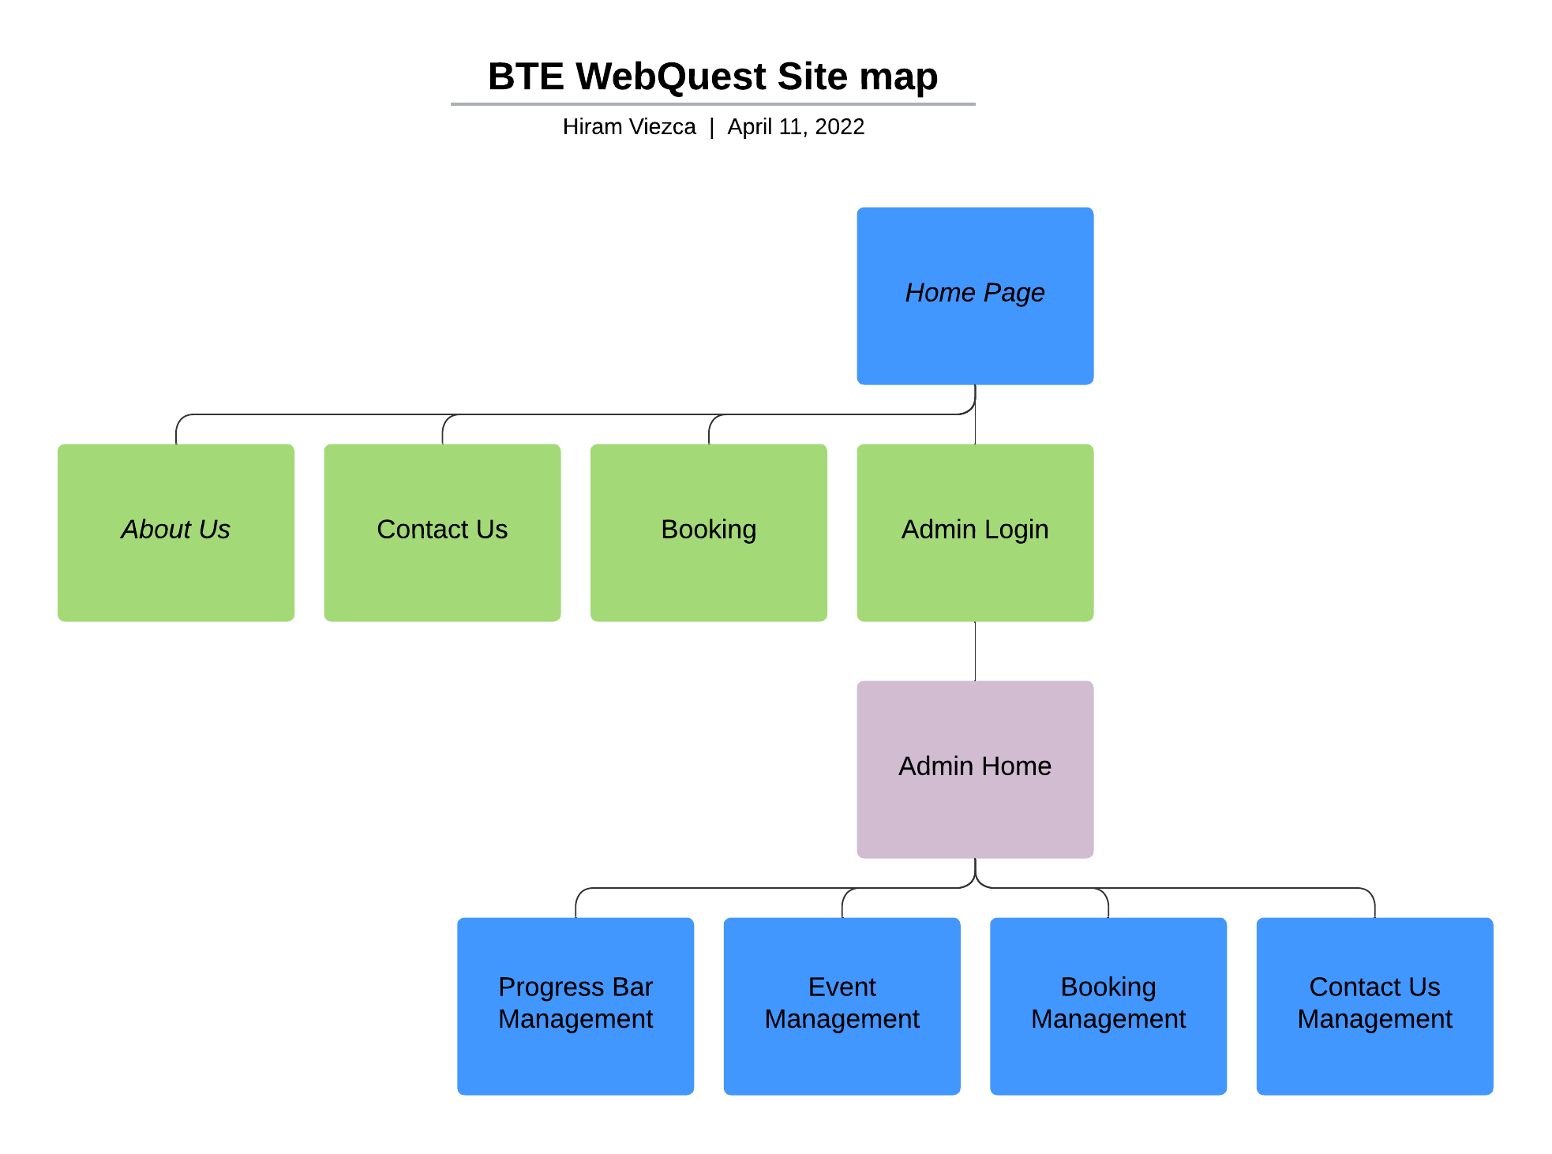

Figure 1-1

The “Main Page” will leverage the Thymeleaf template engine and consist of subsections, or fragments, which can be updated individually allowing for updates that touch only a small part of code. These subsections of the “Main Page” will include the “Now Available” track information, “Coming Soon” album information, video links, event information, and available band merchandise. The information contained in these pages, except for the “Now Available” page, will be updated dynamically from its respective “Admin” page.

The “About Us” page will be a static page as these contain information that will rarely be updated. The “Booking” page will have a form to book the band with a submit button to start the booking process. This form will incorporate data validation to ensure safety of the application as well as accuracy of the visitor’s form input.

All administrative functions for the website will fall under the “Admin” page. This page will be secured behind a roles-based login system using Spring Boot Security. The “Admin” page will provide interfaces for the administrator to update information related to the “Coming Soon” section, event calendar, and work with booking management.

The web application will implement a Model-View-Controller (MVC) design pattern within the Spring Boot application. Individual Controllers will be made for each page to handle all related routing. Models will be used to transport data to all dynamically created sections of the views. This will include models for events, albums, booking requests, admin login, and new material information. Preliminary versions of these models can be seen in Figure 1-2. These models will also interact with Entity models and Repositories for persistent data storage.

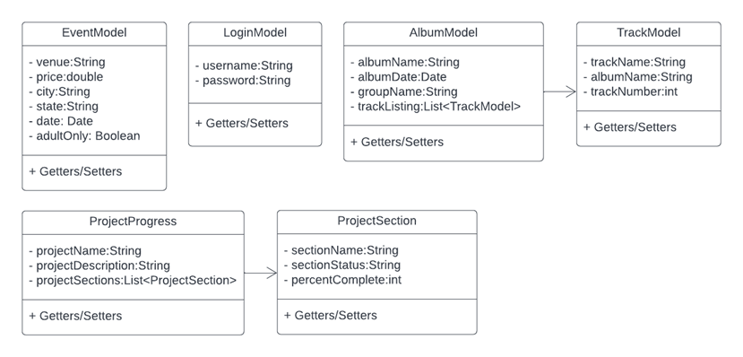

Figure 1-2

All data for the web application will be stored in a SQL Database. Development will be completed using Object Relational Mapping (ORM) through Spring Data JDBC and Entities. This approach allows us to use both MySQL and PostgreSQL with minimal code changes while ensuring compatibility with different cloud hosting solutions.

Application security will be provided through Spring Boot Security. Spring Security will allow the application of security through assigned roles. Identified roles will ensure that access to administrative parts of the web application is restricted to a user logged in with the assigned ‘Admin’ role. An additional role of ‘Editor’ will be created with access limited to updating dynamic web sections.

The development team will use Jira for Agile project management and GitHub for software version control. The web application will be deployed to Heroku cloud services for developmental purposes with a MySQL database for storage as seen in Figure 1-3.

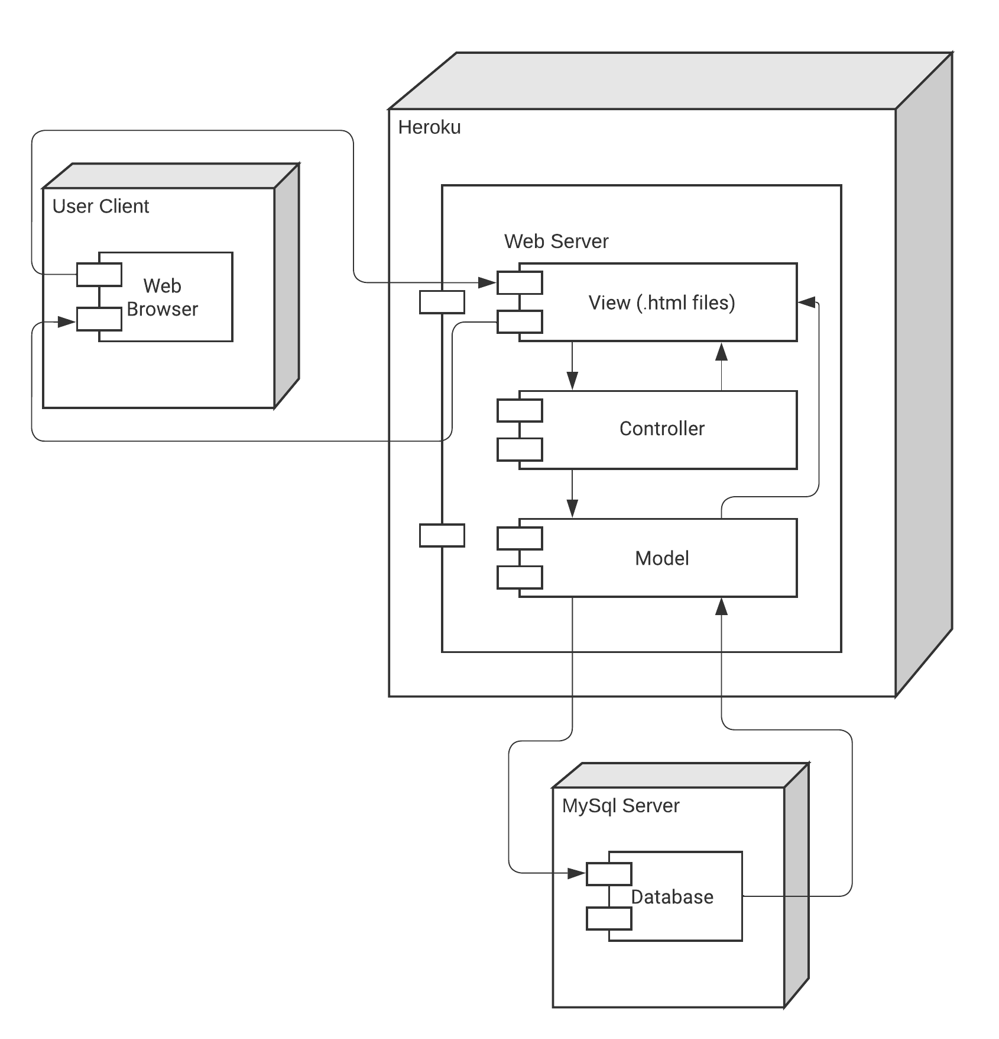

Figure 1-3

# Project Controls

**Risk Management**

|  |  |  |  |  |
| --- | --- | --- | --- | --- |
| Risk Management | | | | |
|  | **Risk Probability** | **Risk Impact** |  |  |
| **Event Risk** | **(high, medium, low)** | **Risk Mitigation** | **Contingency Plan** |
| Breaking the allotted time frame. | Medium | The project will not be completed and could negatively impact our grade. | Using Agile project management for proper planning. Prioritizing jobs and ensuring all team members are having success. | Ensure that major aspects of the project required for minimal operation are completed first. |
| We cannot figure out how to get email notifications to work. | Low | The email notification system will not be working. | Read tutorials and watch YouTube videos to ensure we are ready to attempt coding. | This service does not affect the overall operation of the application and can be completed at a later date. |
| Security of the application is broken | Low | The website can be taken down or changed in an undesirable way. | Strong password requirements will be enforced by the application to ensure security. | No PII or PCI will be maintained by the website, minimizing risk for users. |

**Issues Log**

|  |  |  |  |  |  |  |  |  |
| --- | --- | --- | --- | --- | --- | --- | --- | --- |
| Issues Log | | | | | | | | |
| **ID** | **Description** | **Project Impact** | **Action Plan/Resolution** | **Owner** | **Importance** | **Date Entered** | **Date to Review** | **Date Resolved** |
| 1 | What is the issue? | How will this impact scope, schedule & cost? | How do you intend to deal with this issue? | Who manages this issue? |  |  |  |  |
| 2 |  |  |  |  |  |  |  |  |
| 3 |  |  |  |  |  |  |  |  |

**Change Control Log**

|  |  |  |  |  |  |  |  |  |  |
| --- | --- | --- | --- | --- | --- | --- | --- | --- | --- |
| Change Control Log | | | | | | | | | |
| **ID** | **Change Description** | **Priority** | **Originator** | **Date Entered** | **Date Assigned** | **Evaluator** | **Status** | **Date of Decision** | **Included in Rev. #** |
| 1 |  |  |  |  |  |  |  |  |  |
| 2 |  |  |  |  |  |  |  |  |  |

#### End User Involvement

|  |  |  |  |
| --- | --- | --- | --- |
| Roles and Responsibilities | | | |
| Name | Team | Project Role | Responsibility |
| N’nette Viezca | Testing | Tester | Perform User Acceptance Tests for the application |
| Break the Earth | Client | Owner | Sign off on application acceptance. |

# Project Cost and Schedule

#### Costs

There are currently no costs for the project. Development will be done both locally and hosted on a free Heroku cloud service. Research for a long-term home for the web application and its database will be conducted in the following weeks.

#### Project Schedule

This project will be managed with the Agile methodology. The team will be using Jira to track all aspects of the project and its timeline. The following schedule reflects the project in regard to major Milestones needed. This schedule reflects the four weeks of CST-451 Senior Project 1. Milestones will run weekly beginning 2/28/2022 and ending 3/27/2022.

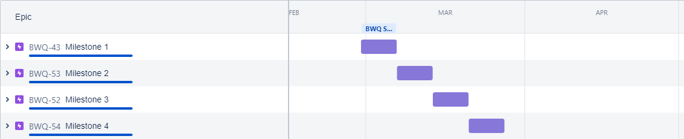

#### Programming Schedule

This schedule reflects the programming aspect of the project. Programming is expected to begin the week of March 7th and last through the 10th of April. Sprints will run from Monday to Sunday to coincide with the class schedule. Sprint review sessions will be held on Saturdays and sprint planning sessions will be held on Sunday to prepare for the new sprint the following Monday. A weekly standup meeting will be held on Wednesday to address any roadblocks for the developers.

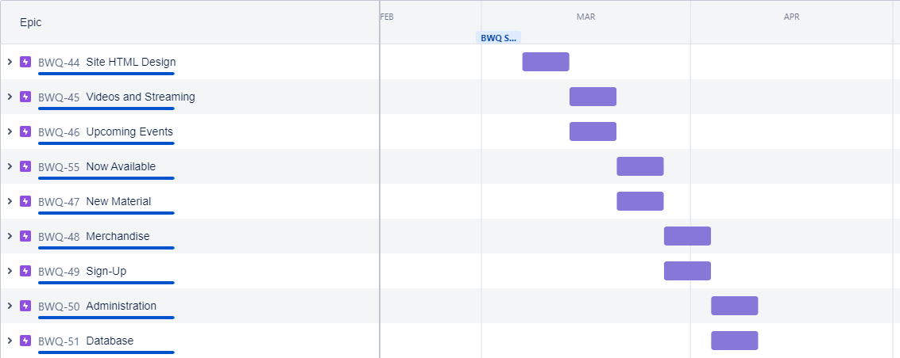

# Appendix A – References

# 

# Appendix B – Copyright Compliance